
STUDENT CASE STUDY EXECUTION REPORT
Department | FED
Subject | DSA -2
Academic year | I – III Semester(2025-26)
Faculty Name | V. GopiKrishna
Student Name | K. Sriram
Roll Number | 2520040072
Branch | ECE
Course Outcome | 4

Case Study Topic : EventSphere Shortest Route Optimization to Event Venues using Dijkstra’s Algorithm
EventSphere is a smart event planning and management platform used for event scheduling, registrations, ticketing, and venue management.
For large events conducted across multiple buildings, organizers and participants need the shortest route to travel between venues.
To optimize travel time, EventSphere stores venue connections as a weighted graph.
Each venue is represented as a vertex.
Distance between venues is represented as edge weight.
For one technical event, the venue network is:
Venue Number | Venue Name
0 | Main Hall
1 | Seminar Hall
2 | Auditorium
3 | Workshop Lab
4 | Exhibition Hall
Distance matrix:

0 4 2 0 0
4 0 1 5 0
2 1 0 8 10
0 5 8 0 2
0 0 10 2 0

Starting venue:

Venue 0

EventSphere must calculate the shortest path to every venue.
Dijkstra’s Algorithm is used.

Question
Using the EventSphere venue routing scenario above:
- Represent venues as weighted graph
- Insert distances
- Start from venue 0
- Compute shortest path
- Display shortest distances
- Perform SLA calculation
- Explain why Dijkstra is suitable

Analysis & Implementation

1.1 Graph representation
Vertices:

0, 1, 2, 3, 4

Weighted edges:

0–1 = 4
0–2 = 2
1–2 = 1
1–3 = 5
2–3 = 8
2–4 = 10
3–4 = 2

Graph:

0
/ \
4/ \2
1---1---2
| |
5| |10
3---2---4

1.2 Shortest path calculation
Source:

Venue 0

Result:

Venue 0 → 0 = 0
Venue 0 → 1 = 3
Venue 0 → 2 = 2
Venue 0 → 3 = 8
Venue 0 → 4 = 10

Explanation:
- 0 → 2 = 2
- 0 → 2 → 1 = 3
- 0 → 2 → 1 → 3 = 8
- 0 → 2 → 1 → 3 → 4 = 10
Shortest routes found.

1.3 Time complexity
Dijkstra:

O((V + E) log V)

For EventSphere:

V = 5
E = 7

Efficient for venue routing.

1.4 SLA calculation
Given:
- Pointer operation = 200 ns
- Budget = 5 ms
Total:

12 operations

Worst-case:

12 × 200 ns = 2400 ns

Convert:

2400 ns = 0.0024 ms

Percentage:

(0.0024 / 5) × 100
= 0.048%

System satisfies SLA.

1.5 Why Dijkstra is suitable
Advantages:
- shortest route calculation
- weighted graph support
- efficient traversal
- fast response
- scalable
For EventSphere:
- organizers optimize logistics
- participants reach venues faster
- event movement becomes efficient

2. Final reasoning
For EventSphere:
- venue graph stored
- shortest routes calculated
- low time complexity
- suitable for venue navigation

Code:

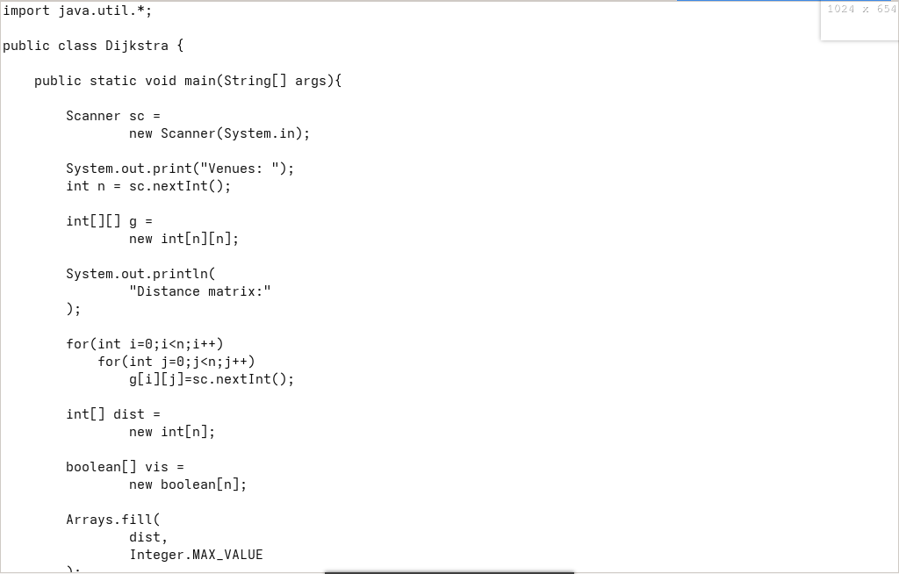

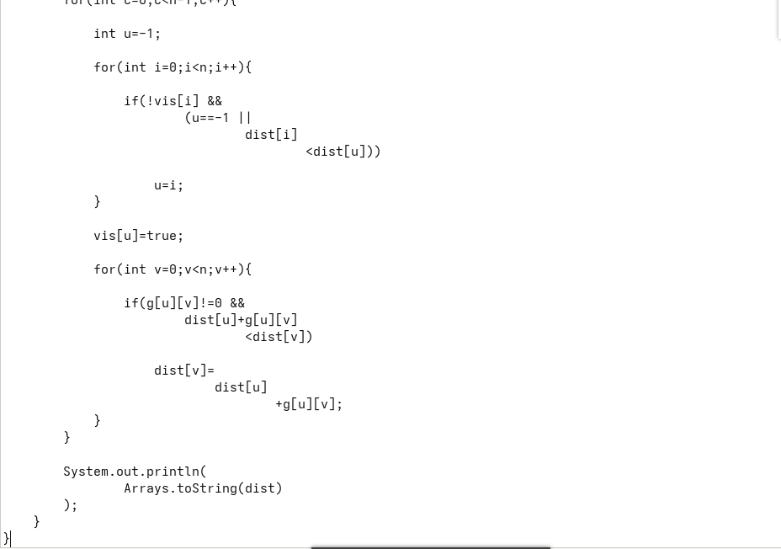

Output:
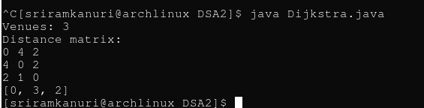

GitHub Link: https://github.com/kanurisriram/EventSphere

Student Signature | Faculty Signature
____________________ | ___________________

